INVITATION TO TENDER

**For the Design & Build of a Skate Park in Ware**

**Closing date and time for submission of tenders:**16/07/2021 - **12:00 midday**

## EXECUTIVE SUMMARY

Ware Town Council is to rebuild and develop a Skatepark for BMX, Scooter, Blades and Skateboards that is to be situated in Ware, Hertfordshire, SG12 9AL on the site of the previous skate park. The site is situated in The Priory Park (see location plan at Appendix I). The site is owned by the Priory Charity and the site’s footprint is circa 952m2 in size and contractors will need to fit all features of the project within this location.

The scheme will restore the previous skate park that was in situ. The skate park will re-establish a much-needed leisure and sporting facility for the local community.

It is the intention to undertake a Design and Build contract for the works. The successful contractor will be responsible for finalising the design and delivering the construction stage of the project. This will involve several key deliverables including the submission a technical design, liaison with the Council & local community, ensuring a safe construction stage and warranting a smooth handover process.

**KEY DATES**

**Tenders are to be returned no later than 16/07/2021, 12:00 hours.**

**Tenders may be emailed to** [**sean@waretowncouncil.gov.uk**](mailto:sean@waretowncouncil.gov.uk) **or by post or hand delivered to:**

The Clerk, Ware Town Council , Ware, Hertfordshire SG12 9AL

**CONTACT FOR THIS PROCUREMENT IS:**

Sean Higgins Finance Manager, Ware Town Council, Ware, Hertfordshire Tel: 01920 460316 Email: sean@waretowncouncil@gov.uk

# PART 1

## INTRODUCTION, TIMELINE & INSTRUCTIONS FOR TENDERERS

### INTRODUCTION

* 1. WARE Town Council (‘the Council’) invites tenders for the design, supply, and installation of a new Skate Park at Ware, The Priory Park, Ware with a budget of £150,000.00 Plus VAT.
  2. The purpose of this document is to give detailed instruction on the form of Tender to be complied with. Any tenders that do not comply with the requirements set out below may be rejected by the Council.
  3. The site is owned by the Priory Charity.
  4. The service and works required for the Skate Park required are outlined in the Design & Build Specification at Part 2, (‘the Specification’). The successful tenderer (‘the Contractor’) will enter into a Design and Build contract with the Council.
  5. The Council will evaluate tenders on the basis of quality (50%) ,price (40%) , Environmental (5%) & Local (5%). The Council does not undertake to accept the lowest, or any, tender submitted.
  6. The Council offers no guarantee that any tender will be recommended for acceptance or accepted and will not be held responsible for any cost incurred in the preparation of any tender.
  7. The Contractor will fulfil the roles of Principal Designer and Principal Contractor for the purposes of the Construction (Design & Management) Regulations 2015.

### PROCESS AND TIMELINE

* 1. The project stages are detailed below.

|  |  |
| --- | --- |
| **PRE CONTRACT STAGE** | **DATE** |
| Issue Invitation to Tender | 25th June 2021 |
| Tender Return Deadline | 16th July 2021 |
| Tender Evaluation | 19th – 21st July 2021 |
| Contract Awarded / Approval at Full Council | 26th July 2021 TBC |

|  |  |
| --- | --- |
| **DESIGN AND CONSTRUCTION STAGE** | **DATE** |
| Contract Design Works Commence | XX July 2021 TBC |
| Feedback/Adjustment to Designs Agreed | *To be agreed* |
| Date of Commencement | *To be agreed* |
| Date for Completion | *To be agreed* |

* 1. The timetable set out above is intended as a guide only. The Council reserves the right to terminate, amend, or vary the procurement process at any time.

### INSTRUCTIONS FOR TENDERERS

* 1. Tender prices must remain open for acceptance for 12 months from the submission date. Please advise if this is not possible.
  2. The Contract will take the form of an exchange of letters based on these preliminaries.
  3. Tenderers shall clearly identify the construction material for each element and provide a guarantee of the life expectancy of the facility, which should accompany the designs.
  4. Tender prices must include for an independent post installation inspection by an RPII certified inspector. The report is to be issued to the Council as part of the handover process.
  5. Without prejudice to anything contained within the Specification, the Tenderer will ensure that any equipment installed is well designed, limits the opportunity for vandalism and has low maintenance aspects to minimise maintenance re-visits. Equipment provided should demonstrate ease of maintenance and access to serviceable parts.
  6. In the absence of specific direction to the contrary, the Tenderers price must be fully inclusive, including contingency, covering all labour, materials, temporary works, plant, groundwork preparation, overhead charges, and profit, as well as the general liabilities and taxation payable in so far as any is due, obligations and risks described or implied in the tender documents. Costs relating to items which are not priced will be deemed to have been included elsewhere within the Tenderers budget. For the avoidance of doubt the Tender price will also be deemed to cover all contingencies or costs overruns.
  7. In the interests of fair competition if Tenderers discover any anomalies or ambiguities in the bid documents, they are requested to bring them to the Council’s attention as soon as possible so that clarification can be provided to all interested bidders.
  8. Should any Tenderer be in doubt as to the interpretation of any part of this ITT, the Tenderer shall submit a request for clarification to the Council.

# PART 2

## DESIGN AND BUILD SPECIFICATION

### GENERAL REQUIREMENTS

* 1. The Council is looking for an innovative design that incorporates anti-vandalism into the build and makes best use of the space available. Elements included will offer multiple uses and rideable features suited to intermediate to advanced users.
  2. Submit 3 designs for the area with the approximate dimensions.
  3. The footprint of the existing tarmac apron for the new BMX/Skate Park facility measures 34 m x 28 m (approx. 952m2).
  4. The following features should be included in the ramp design:
* Concrete structure throughout
* Improvements in durability of the surface and in particular to prevent wear from scooter users. Two single small wheels cause more wear than BMX and skateboard users.
  1. The overall design should consider :
* Should be suitable for all roller sports equipment & and BMX bikes
* must provide multiple line choices and good flow around the whole park
* A mini ramp
* A box feature
* Street elements : a manual pad & a Pole-jam
* Access points and circulation space.
* Limiting and discouragement of anti-social behaviour where possible.
* Limiting of noise emissions where possible
* Provision of benches for spectators
* Provision of a suitable waste & recycling bins
* Potential addition of further Skatepark features at a later date therefore the best possible use of the space available to not prevent any further additions to the Skatepark at a later date.
* Details must be provided regarding an adequate system for drainage from the Skatepark
* Full Details must be provided in relation to the types of concrete C25, C35 & C45 being used in each section of the skatepark
* Land survey to determine that the current surface can support the concrete structure
* Full Review of the current surface’s suitability prior to the commencement of any works
* The fence around the outside will be removed prior to commencement of works
  1. All aspects of the design must confirm to the British Standard – Facilities for Users of Roller Sports Equipment - Safety Requirements and Test Methods, ref: BSEN14974:2019 and satisfy the recommendations of RoSPA’s ‘Prevention of Skateboarding Accidents and Litigation Management’.
  2. Any equipment shall be installed as per the manufacturer’s instructions and adhere to RoSPA recommendations. A Post Installation Inspection must take place upon completion and the cost included in the Tender.

### KEY CONSIDERATIONS

* 1. Limiting noise emission and anti-social behaviour are key considerations and should clearly inform the choice of materials, specification and/or design used in construction. The Tenderer should address these details in their submission.
  2. Proposed measures to minimise noise emission and minimise the opportunity for instances of anti-social behaviour to occur must be clearly demonstrated in the Tender. These measures may include proposals relating to the layout of the ramps, choice of structure, design concept, surface material or any other factor. Inclusion and reference to these factors will influence the decision by the Council for the chosen Tender.
  3. The facility should cater for users of skateboards, wheels (e.g. BMX & scooters) and skates. Consideration is to be given to providing a smooth ride, popular with the original design, whilst providing a challenging facility for more experienced users.
  4. Contractors are advised to visit the site to familiarise themselves with the identity and layout of the site to make best use of the existing site assets including trees, topography and access points. **Arrangements for visiting site must be made through the Council.**
  5. The BMX/Skate Park should be designed as a destination park for families and spectators to appreciate, as well as riders. Give consideration to avoiding user conflicts within the space, such as including viewing platforms, which can be enjoyed by non-riders without obstructing the flow of the skate park.
  6. Designs received will be subject to technical evaluation and consideration by a variety of stakeholders.

# PART 3

## PRELIMINARIES/GENERAL CONDITIONS

**Schedule of Contract Conditions (WARE Town Council standard conditions, clauses 1 to 36 with supplementary clauses 37 to 43).**

**Overview**

Clause 1 WARE Town Council (hereafter ‘the Council’) places all orders for goods and services under the Terms and Conditions of this document ‘Terms and Conditions of Purchase of Goods and Services’.

Clause 2 All written communications with the Council shall be addressed to The Clerk, Ware Town Council, Ware, Hertfordshire SG12 9AL

Clause 3 Communication by e-mail is acceptable if addressed to [clerk@](mailto:clerk@southwater-pc.gov.uk) Waretowncouncil.gov.uk(or [sean@Waretowncouncil.gov.uk](mailto:sean@waretowncouncil.gov.uk%20) ). However, a transmission of any e-mail that demands electronic acknowledgement of such an e-mail will not be accepted as proof of delivery.

**Obligations of Terms and Conditions**

Clause 4 The Contract shall comprise only the Council’s Specification where applicable, the official order, Terms and Conditions of Contracts and these Preliminaries, in that order of precedence.

Clause 5 The official order addressed to a designated authorized officer (generally the Clerk to the Council) together with these Terms and Conditions, comprise the entire contract between the Council and the Contractor.

Clause 6 No terms and conditions put forward by the Contractor (including terms relating to hire, lease or loan) shall form part of the contract unless included in the official order.

Clause 7 Unless the Council expressly agrees in writing, every party shall be governed by these conditions, to the exclusion of all other conditions.

Clause 8 By taking action against an official order, the Contractor will be deemed to have accepted these Terms and Conditions in their entirety.

Clause 9 A delivery note stating the price and the order number (if quoted on the official order) must accompany each delivery of goods.

Clause 10 The price identified in the official order is fixed unless otherwise stated. When referring to the supply of goods, the price includes delivery by the Contractor to the destination(s) stipulated in the official order.

Clause 11 Property and risk – any goods which pass acceptance by the Council, or, in the case of delivery in instalments, on acceptance of each instalment.

Clause 12 Goods and services which conform in every respect to the specifications and drawings, samples or descriptions provided shall be to the satisfaction of the Council. If requested by the Council, the Contractor shall supply, free of charge, certified copies of records of inspection and testing to confirm such compliance.

Clause 13 Without prejudice to any standard required elsewhere in the contract, all goods and services shall conform to any applicable specification or code of practise issued by the British Standards Institution or the International Standards Organization, those current at the date of the proposal.

Clause 14 In addition to Clause 13, the Contractor warrants (in the case of goods) that the goods are of satisfactory quality and fit for purpose for which it is supplied, (in the case of services) that it will provide the service with reasonable skill, care and diligence.

Clause 15 All terms implied by statute in a contract relating to this order shall be binding on the Contractor. It shall be the responsibility of the Contractor to deliver the goods to the Council and they shall be at his risk during transit.

Clause 16 If goods and services do not comply with the official order, or any condition of the contract are not complied with, or it is clear that the Contractor will not be able to perform his part of the contract, then, without prejudice to any other rights or remedies the Council may have, it may (at its discretion) reject the goods or services (or part of them) and/or cancel the official order (or part of it) by giving written notice to the Contractor to cancel the supply of goods or services, replace or rectify the goods or services to the Council’s satisfaction, or carry out, at the Contractor’s expense such work as may be necessary to make the goods or services comply with the contract.

Clause 17 The supplier shall, free of charge, immediately repair or replace (as the Council shall elect) goods which failed to arrive, are damaged or not fit for purpose following which the Contractor shall forthwith repay to the Council any money paid by it for rejected goods or services.

Clause 18 The Contractor shall comply with Council policies, i.e., Council terms, and particularly any that are brought to their specific attention, e.g., procedures as to goods, etc.

Clause 19 The Contractor shall not sub-contract the official order or any part of it without the prior written consent of the Council

Clause 20 The Council would cancel this contract and recover from the Contractor any loss resulting from such cancellation if the Contractor or any person acting on his behalf shall have offered, given or agreed to give any officer or member of the Council any gift or consideration of any kind as an inducement or reward in respect of the contract, or shall have committed any offence under the Prevention of Corruption Act 1889 to 1916 or Section 117 of the Local Government Act 1972.

Clause 21 The Council may cancel this contract if the Contractor becomes bankrupt or insolvent.

Clause 22 The Contractor shall be liable for and it indemnifies the Council, its employees, agents or contractors against all proceedings, liabilities, loss, damage, claims, costs and expenses whatsoever arising, directly or indirectly, out of or in the course of or in connection with the supplies supplied or value of said goods or provision or value to provide services. The Contractor shall maintain insurance policies containing an indemnity to principles clause with a reputable insurer to cover such liability and it should provide evidence of this if so requested by the Council.

Clause 23 The Contractor shall not infringe an intellectual property right of any third party. Clause 24 The intellectual property rights not in specifications information instructions, plans,

drawings, patterns, models, designs whatever material made valuable to the

Contractor by the Council or obtain on the Contractor in connection with the contract shall remain vested solely in the Council and intellectual property rights in anything arising out of the supply shall be based in the Council.

Clause 25 The Contractor shall comply with all applicable legislation, including, but not limited to, the Health and Safety at Work Act 1974, Race Relations Act 1976, Sex Discrimination Act 1975, and the Disability Discrimination Act 1995, the Human Rights Act 1998, General Data Protection Regulations 2018, or any statutory modifications or renegotiations thereof.

Clause 26 The Council must protect the public funds it handles and therefore it may use the information the Contractor gives relating to this order (e.g. invoice) to prevent and detect fraud. It may also share this information for the same period with other organisations which handle public funds.

Clause 27 Subject to Clause 28, the parties, their employees and agents, shall keep same and not disclose any information provided in confidence, without the prior written consent of the other parties, except as may be necessary for the performance of the contract. The deed of confidentiality shall not apply to any information (i) in the possession of the party concerned, without restriction as its disclosure before receiving it from the disclosing party or (ii) received from a third party who lawfully claimed it and who is under no obligation restricting its disclosure; (iii) has or becomes public knowledge (otherwise than by breach of this clause) and (iv) liable to disclosure under the Freedom of Information Act 2000 or any other legislation.

Clause 28 The Contractor shall assist and co-operate with the Council to enable it to comply with the obligations under both the General Data Protection Regulations 2018 and the Freedom of Information Act 2000 respectively.

Clause 29 The Contractor shall confirm that it is fully compliant with the General Data Protection Regulations 2018 providing a copy of the Company’s ICO Registration, and once any contract is let must ensure that all personal data is redacted if such material is retained by the Contractor.

Clause 30 If either the Council internal or external auditors investigates the contract, the Contractor shall provide such information, access and co-operation as this person may reasonably require.

**Financial Conditions**

Clause 31 The Contractor shall deliver a detailed invoice as soon as possible after acceptance of the goods or services, unless otherwise specified in the official order.

Clause 32 Invoices will usually be paid within thirty days of receipt. Clause 33 Payments are generally only made once a month.

Clause 34 If provided on the official order, the Contractor must quote the order number(s) on the invoice. Failure to do so may incur a delay in payment.

Clause 35 Under no circumstances will a deposit or other preliminary payment be made.

Clause 36 If written in writing, such payments may be made against specifically identified projects, or service milestones.

**Supplementary conditions**

Clause 37 The Contractor shall supply a priced schedule with his tender together with a cashflow chart related to the programme. Notwithstanding the cashflow chart, interim and final payments will be related to actual progress. The cashflow chart should show the value on the completion of the design. (do we need to include this ?)

Clause 38 Upon appointment the Contractor shall proceed with the design of the new structure but shall not under any circumstances proceed with any ordering, procurement or fabrication until such time as he has received approval in writing from the Employer. Once payment has been made for the design (less any retention) the design shall become the property of the Employer.

Clause 38 In the event of default by the Contractor the works completed to date will become the property of the Employer. This includes any design that has been completed at that stage.

Clause 39 Interim payments will be subject to retention of ten per cent, half of which will be released on Completion of the Works. The balance of retention will be released after 12 months or the completion of making good of any defects whichever is the later.

Clause 40 The Contractor shall make good properly and expeditiously any defects that may be found as a result of inadequacies in the design, materials or workmanship during the period of 12months following certification of acceptance of the Works as being complete.

Clause 41 Employer’s and Public Liability insurance shall have a limit of indemnity of not less

than £10 million.

Clause 42 The Freedom of Information Act 2000 came into force for local authorities on 1st January 2005. It affects all information held by local authorities. It is a matter of law and local authorities cannot contract out of it. The Council currently expects the position as to what information may be accessible to the public, to be as follows. However, it can give no guarantee that this will continue to be the case, as the legislation develops and as the Information Commissioner issues decisions in this area. Nor can the Council give any commitment that it or other Customers may not be required or feel obliged to make information available to the public or to withhold it on some other basis. By submitting your tender, you are taken to accept this.

|  |  |
| --- | --- |
| **Information** | **How it is Treated** |
| Tender Submissions | Will be treated as publicly inaccessible at least until the successful tenderer has exchanged letters with the Council to confirm the Contract. |
| Identity and Amount of Tenders | The identity and amount of the successful and unsuccessful tenderers will become publicly accessible only after award. Tenderers will continue to have their existing rights to know details about their own tender, but not of others. |
| Trade secrets and other information that is genuinely commercially confidential | The Council is obliged not to disclose information that is genuinely confidential (such as the formula for making a particular product). However, the Information Commissioner has made it clear that this cannot be used as a blanket justification for refusing access, and that council’s may not agree to treat information as confidential unless there is a really strong justification for doing so. |

Clause 43 The contract will be terminated if the contractor or anyone on its behalf bribes or tries to bribe anyone in connection with any contract, or commits an offence under the Prevention of Corruption Acts 1889-1916. The Council takes these issues very seriously. It encourages all Contractors, tenderers or for that matter anyone else, to contact it if any Councillor, employee or other Contractor, tenderer or potential tenderer approaches them and either attempts to engage them in any such activity or infers that they could do so. Hence, you should not attempt to canvass any Member or Officer of the Council about your tender or try and obtain confidential information relating to the tendering process from anyone associated with the Council or from any other past or present contractor to the Council. If you do so your tender is likely to be rejected.

**APPENDIX 1**

**Location Plan**

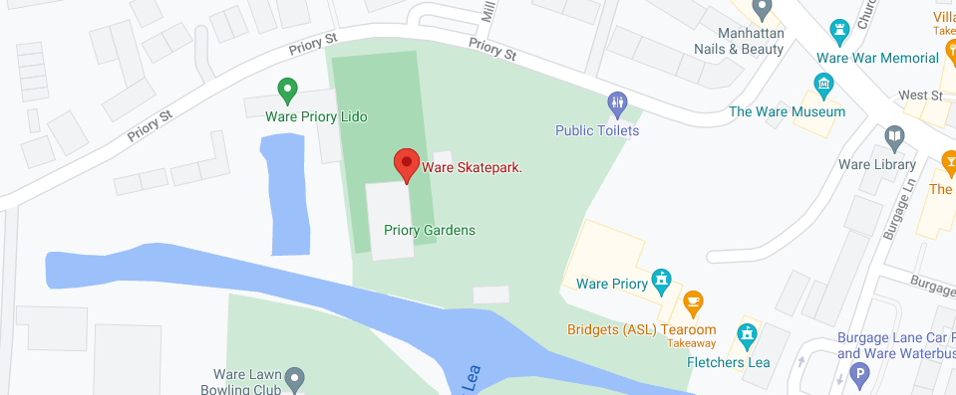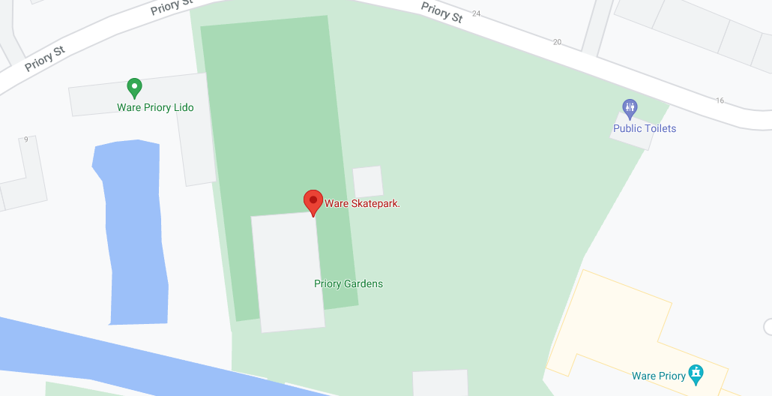

**Photo of Access Route**

**Easy access via the gated entrance leading to the side of the Skatepark.**

