Ware Shares Technician 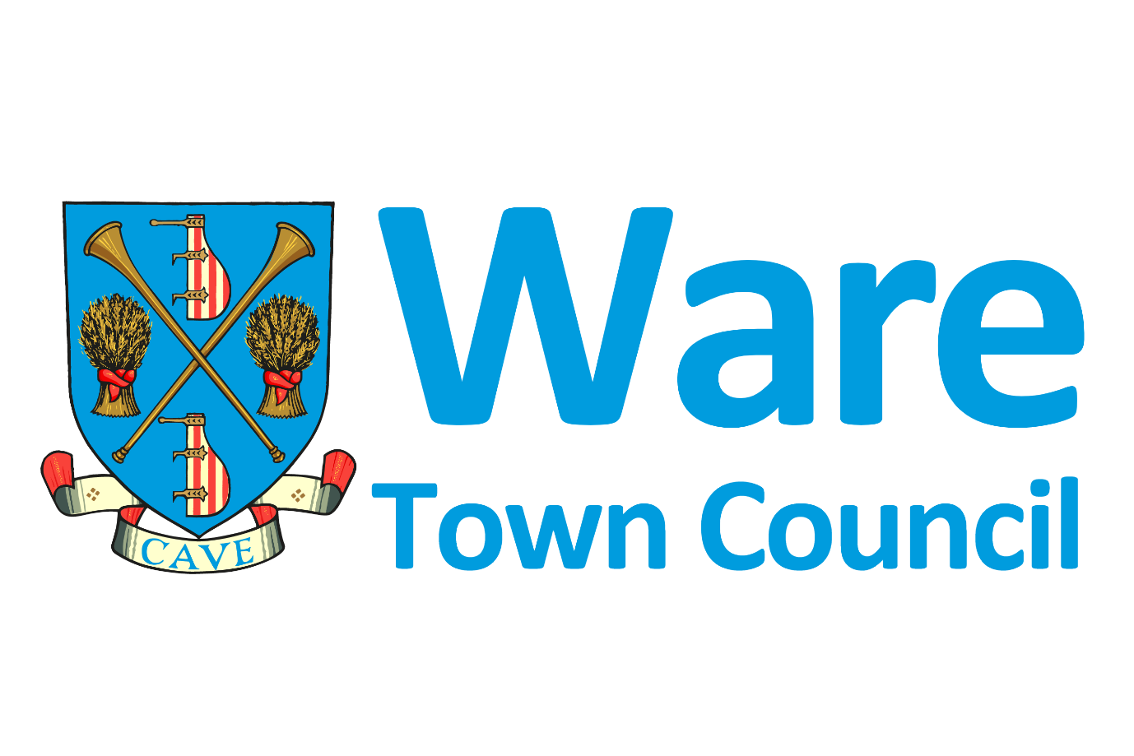



Ware Town Council
The Priory
High Street
Ware
Hertfordshire
SG12 9AL
Telephone 01920 460316

Dear applicant
Thank you for your interest in applying for the role of Ware Shares Technician.
This pack is designed to give you more information about the role and our organisation.
An interesting and rewarding new position has become available with Ware Town Council. We’re looking for someone with an enthusiastic interest in serving the community and an aptitude for working with tools although specific training will be provided. Working closely with our Ware Shares partners and our locker hosts, you will be enabling the success of our sustainable borrowing service for the residents of Ware and surrounding areas.
You will take the lead on managing the tool maintenance service, ensuring tools are kept clean, safe and fit for purpose so that they are ready for the next borrower. This project is part of the Council’s drive for more sustainable services in Ware.
You will need to be able to work independently and manage the borrowing workload with the support of our Ware Shares partners. The applicant must have confidence in communicating technical matters clearly and providing regular updates.
The role will be 8 hours a week, split over 2 half days. It is anticipated that a Monday afternoon and Thursday morning/afternoon would best suit the service, however there is some flexibility with specific days.
Ware Town Council is committed to Equality of Opportunity and actively welcomes applications from all sections of the community.
Please note that we only accept applications using our application form; this is tailored to each role and aims to ensure we get all the information from you that we need to be able to shortlist for interview. Please ensure that the form contains all the information that you want to get across.

Completed forms should be emailed to Heidi Pateman, Climate & Biodiversity Manager Heidi@waretowncouncil.gov.uk by 5pm Friday 29th November 2024.
If you would like an informal discussion or more information about the role and our organisation please contact me on 0777 5037303 during working hours.
Your faithfully

Heidi Pateman
Heidi Pateman
Climate & Biodiversity Manager




JOB DESCRIPTION

JOB TITLE: Ware Shares Technician
PLACE OF WORK: The Priory

SPINE POINT: SCP 14 to 17

HOURS OF WORK: 8 hours a week (2 half days)

REPORTS TO: Climate & Biodiversity Manager

A Ware Shares – Main Purpose of the Job

Ware Shares is a community service enabling residents to borrow DIY, gardening and leisure tools at a fraction of the cost of buying them. This scheme is central to our ethos of sustainability in helping the community to save money, space and waste together with the emissions associated with purchasing tools that often end up covered in dust at the back of our cupboards.
The scheme is powered by the Library of Things software and tools will be located in the Ware Shares lockers at Asda.
Tools will need collecting, checking, cleaning and repairing as required in our specially designed Technician’s workshop, then returning to the lockers in time for the next borrower to use.

B Areas of Day-to-Day Responsibility

- To fully support Ware Shares, enabling it to become a thriving community service.
- To use the Library of Things software to monitor tools returned to the lockers that are in need of checking, prioritising those that are most likely to need maintenance.
- To collect returned tools from the lockers situated in Asda, using the trolley provided and bring them back to the Technician Workshop, based at the Priory (3-4 minute walk).
- To carry out a thorough check of tools, clean and repair as required. For example this will include tasks such as troubleshooting reported issues, inspecting blades, replacing hand sander pads, checking cabling etc.
- To carry out occasional Portable Appliance Testing (PAT) of necessary things to ensure they are safe (training provided).
- To order spare parts if needed and alert the Library of Things Support Team that the tool will be delayed so that the next borrower can rebook.
- To advise the Library of Things Support Team if additional borrower charges are required due to neglect or accidental damage.
- To return tools to the Ware Shares lockers in Asda and update the Library of Things software to show that tools are available for the next borrowers.
- To keep the lockers stocked with consumable supplies such as sandpaper, strimmer blades etc.
- To carry out basic maintenance of the lockers including troubleshooting if systems go down.
- To protect Asda customers from accident by ensuring the floor around the lockers is free from water spillages potentially leaking from tools.
- To interact with the general public and Asda staff in a polite and professional manner as required during tool collections/returns.
- To keep an eye on urgent emails daily.
- To provide a weekly update to the Climate & Biodiversity Manager and keep in close contact with the Library of Things Technician Support Team.
- To convey ideas for improvement as bugs will inevitably occur during the early days of the scheme.
- To assist the Climate & Biodiversity Manager in the writing of a procedures manual to enable volunteers to cover the post effectively at times of annual leave or sickness.
- To work with the Climate & Biodiversity Manager to actively promote the scheme.

Working Environment
Based at The Priory in the specially designed Technician’s Workshop. The Council operates a smoke-free policy and the postholder is prohibited from smoking in any of the Council’s buildings. All staff must commit to Equal Opportunities and Anti- Discriminatory Practices.
Ware Town Council Values
To work in a way that embodies the Councils values: -
Adaptable  Accept and work with change | Forward thinking  We start with the end in mind
Willing to adapt work practices to support team members working together to resolve issues, meet targets, deadlines and challenges.  Move out of our comfort zone and question how we do things.  Work with others to meet joint challenges and reduce duplication. | Initiative: We are proactive and use our creativity to identify and resolve problems.  Strive for excellence: We will seek innovative solutions to reduce costs, identify new ways of working and generate income.  Plan ahead – anticipate outcomes ahead of changes.  Use new technologies and working practices to make service improvements and reduce costs.
People Orientated  We are one team with common goals. | Integrity  We are honest and open in all our dealings and deliver on our promises.
Customer focussed: We understand and aim to meet our customers diverse needs, treating them fairly and with respect.  Expertise: We recognise and value the differences, skills, knowledge and experience of all in our team.  Empowerment: We encourage team members to take initiative.  Listen to improve: Engage with residents and staff; be seen, invite feedback and consult with them to inform our improvement plans.  Always be approachable, calm and respectful.  Clearly communicate our decisions, without using jargon. | Accountable: We are accountable for our actions-admit mistakes, put them right and learn from them.  We challenge poor or unfair practice and feedback.  Keep personal data confidential and secure.  Consistency: We ensure consistency and transparency in all we do  Professionalism: We act professionally in challenging situations.

Equal Opportunities and Anti-Discriminatory Practices
All staff must commit to Equal Opportunities and Anti-Discriminatory Practices.

Health and Safety at Work
The Town Council's Policy, and all relevant Health and Safety at Work Instructions are to be considered as part of this job description.

Data Protection Act 2018
All employees who are involved in the processing or handling of computer data have an obligation to comply with the terms of the Data Protection Act 2018 and the Council's Data Protection Policy.
Council Policies
The post-holder is expected to familiarise themselves with and adhere to all relevant Council Policies and Procedures.
Performance Management
You will be given an annual appraisal and six-monthly review that will form the basis of your Personal Development Plan and be linked to the Council’s objectives. You will also receive collaborative one to one meetings on a regular basis with the Climate & Biodiversity Manager.
Environment / Sustainability
To support Ware Town Council’s Environmental initiatives and consider the environmental impact of all activities undertaken.
WARE SHARES TECHNICIAN
PERSON SPECIFICATION
 | Essential Attributes | Desirable Attributes
Educational  Qualifications | 4 GCSEs or equivalent (NVQ)  A commitment to further development, including 3 days training in London (costs paid) with the Library of Things Technician Support Team and any health & safety training deemed necessary. | Training &/or knowledge of basic tool maintenance including :  - Use of typical DIY repair tools  - Replacing basic electrical parts  - Replacing basic plumbing parts  Training &/or knowledge of health & safety practices
Communication Skills | Good oral communication skills  Ability to remain polite, calm and professional when coming into contact with the general public. | Good written communication skills
Reporting | Ability to operate basic computer software (Library of Things – training provided)  Ability to provide regular updates and convey ideas for improvement | Ability to write clear processes
Knowledge and Experience | An aptitude for working with tools and carrying out general DIY tasks | Prior experience in maintaining tools
Skills | Ability to work alone (with support), organise own workload effectively, prioritising tasks and making informed decisions to deliver results.  Good organisational skills  Good general maintenance skills  Forward thinking and proactive
Information  Technology | IT literate with experience and practical ICT skills
Other | Passionate about communities and communities led initiatives.  A positive “can do” attitude and willingness to support others where needed.  A flexible approach to working and the ability to respond at short notice to changing priorities.  Physically able to transport tools from Asda to The Priory in a trolley (3-4 minutes walk).

Selection Process and Interviews
Date
1st November 2024 | Role advertised
29th November  2024 (5pm) | Closing date for applications. A shortlisting panel will review each application and score how well you meet the essential and desirable attributes on the person specification.
2nd December 2024 | Shortlisted applicants invited for interview by email.
Week commencing  9th December 2024 | Interview to interview panel, details to be confirmed with the interview invitation.  Interviews will be held at The Priory in Ware.
To be confirmed | Start date

Principal Terms of Employment
Job Title: Ware Shares Technician
Salary: Local Government scale point (SCP) 14 to 17
Salary range £15.21 per hour to £15.99 per hour including location allowance
Holiday: You will receive 25 days paid holiday pro rata, plus bank holidays
Hours of Work: The role is 8 hours per week consisting of two half days
Probation: New starters are subject to a six-month probationary period
Appraisal: All team members undergo an annual appraisal
Pension: You will be enrolled in the Local Government Pension scheme

Other benefits:
Training relevant to the role including 3 days in London with Library of Things Technician Support Team (costs paid)
Employee Assistance Programme
Flexible working
Sick pay
For more information please contact
Heidi Pateman, Climate & Biodiversity Manager, Ware Town Council
0777 5037303
heidi@waretowncouncil.gov.uk

Ware: The Local Picture
Ware is a town of around 19,800 people in Hertfordshire, England close to the county town of Hertford, and lies on the River Lea. It is also a commuting town for London, with regular rail services between Ware railway station and London Liverpool Street
The town lies on the north-south A10 road, and the east-west A414 (for Hertford to the west and Harlow the east).
Ware has many listed buildings by Historic England, many timber framed, four grade I, fifteen grade II* and 181 grade II, including the remains of a fourteenth-century friary, now the local council offices and a conference centre called The Priory and Fletcher's Lea.
The town is also famous for its many 18th-century riverside gazebos, several of which have been restored recently.
Today the town's main employer is GlaxoSmithKline which has a large plant in the town.
The Town has many local community groups, a Sports and Leisure Centre at Wodson Park and an open-air Lido in the grounds of The Priory.
Management of the Council
Ware Town Council – an overview
There are three tiers of local government locally, each with different responsibilities.
Ware Town Council is the first and most local tier, with an important role to play in promoting the town, representing its interests and supporting the work of different groups in the community. Decisions made by the Council will be made at formal meetings which are open to the public.
In December 2023 Ware Town Council achieved Gold Accreditation in the local council award scheme, one of only 57 councils in the country. Terry Philpott, Town Clerk was awarded the National Association of Local Councils Clerk of the Year for 2022.
Councillors:
The strategic direction for the Council is provided by its 11 elected Councillors who represent five wards across the Town. Elections are held every four years, the next being in May 2027.
Each year, the Council elects from amongst its members the Town Mayor and Deputy Town Mayor.
Councillors are unpaid and receive no allowance for their duties. There is, however, a small allowance given to the Mayor to meet any expenses involved in fulfilling the Mayoral duties.
East Herts District Council is the second tier and is responsible for services including car parking, waste management, housing, planning applications and street cleaning.
Hertfordshire County Council’s responsibilities include highways (relating to both roads and pavements), education, health and social services, public rights of way and libraries.

