

**WARE TOWN COUNCIL MEETING**

will meet on

**Monday 27th January 2025**

in The Priory Hall, The Priory, Ware, starting at 7.30pm

All Members of Ware Town Council are summoned to attend the above meeting when the following business will be transacted:

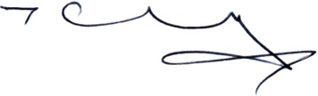

Terry Philpott, Town Clerk

22nd January 2025

This meeting is open to the Public and Press. The Council provides opportunity for members of the public to speak or ask questions at every meeting of the Council on any item on the agenda. Requests for items to be included on the agenda should be notified to the Clerk by the first Monday of the month.

# A G E N D A

**WTC938: To receive and accept Apologies for Absence**

**WTC939: To receive any Declarations of Interest and review any requests for Dispensation submitted to the Clerk.**

**WTC940: Minutes from the previous meeting:** to receive and sign the minutes of the last Town Council meeting held on 13th January 2024

**WTC941: Fairtrade (TP/15mins)**

Presentation from Tony Dodds Fairtrade.

**WTC942: Tudor Square (TP/10mins)**

To consider the views of WTC in relation to the proposed changes to Tudor Square.

Hertfordshire County Council (HCC) is proposing the introduction of Police parking bays in Tudor Square, as outlined in the attached plans.

At the same time, a Restricted Parking Zone and a Pedestrian and Cycle Zone will replace the existing Pedestrian Zone. The existing rising bollard will be decommissioned.

Signage will be rationalised to match the proposed restrictions and to declutter.

Should the scheme progress to formal public consultation, a planning application will be submitted to accompany the scheme, and both would need to be concluded successfully for the scheme to progress.

HCC invites you to provide comment on the proposal, which you may do via email response to Ross Corben [Ross.Corben@hertfordshire.gov.uk](mailto:Ross.Corben@hertfordshire.gov.uk) by Friday 31 January 2025. Resident and business owners in the affected area will also be consulted via letter.

**WTC943: 20MPH Consultation (TP/10mins)**

To consider the 20mph proposals and the councils response.

Last autumn HCC consulted on a proposal to introduce a 20mph zone in Ware. This proposal involved reducing the permitted speed to 20mph in 95 streets including the High Street. Given the lack of overall support for the proposal and mixed response from residents affected, a decision was taken to not proceed with the scheme. Since then, HCC have been working closely with local councillors to identify smaller areas to be considered for 20mph, focusing on roads around schools and town centre roads with high footfall.

As a result, HCC are now developing a revised proposal focused around the High Street of Ware. This would link up the existing restriction on Baldock Street and High Street with those at Bowling Road, The Close, Church Street, Collett Road and The Bourne to create a more coherent 20mph zone. A drawing of the proposed 20mph zone is attached to this email.

The existing 20mph signing on the High Street was introduced as part of a package of emergency social distancing measures as part of our response to the Covid 19 pandemic. Following the resumption of normalities, most of the social distancing measures were removed, however, the 20mph signs were left in place. The current 20mph signs on Baldock Street and High Street have remained in place far longer than anticipated and unfortunately the associated temporary traffic regulation order has expired. Their continued presence is confusing to road users and is creating enforcement difficulties for local police officers. To address these issues, it will be necessary to take down the existing signage and then advertise a new traffic regulation order to reintroduce 20mph.

**WTC944: Correspondence and Clerks report (TP/5mins)**

Lido Building refurbishment

Fletchers Lea Refurbishment

Priory Lift update

Priory Grounds toilet refurbishment, opening event to be planned.

ATC visit January / February on Monday / Wednesday to view flight simulator.

CRP Railway 200 May 25th 2025 tbc

Planning Decision Peregrine House

**WTC945: Grant applications (SH/2mins)**

To receive an update on grants allocated by officers and review any grants for consideration by Full Council.

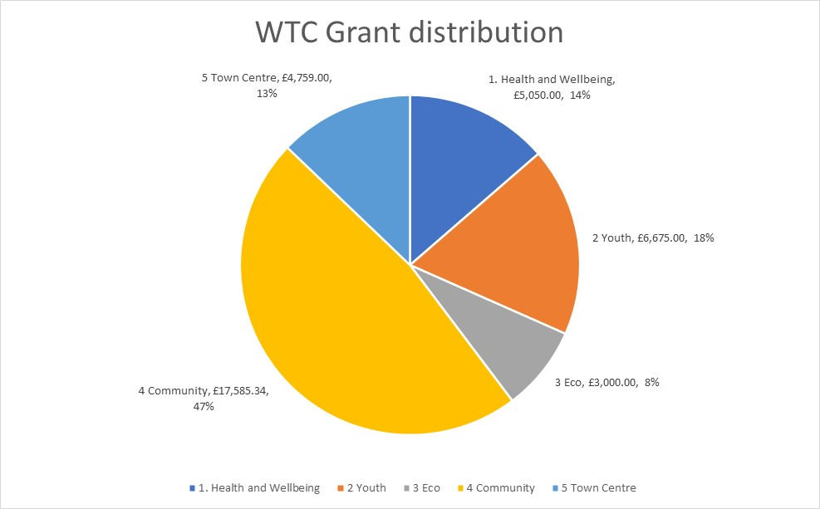

**WTC946: Cemetery and Allotment report (TP/DM 5mins)**

To note the Cemetery and Allotment report

**WTC947: Eco and Biodiversity report (HP/15mins)**

To note the Eco and Biodiversity report

**WTC948: Financial Report (SH/TP 5mins)**

Finance reports to 31st December 2024

* Bank Reconciliation inc reserve, earmarked funds.
* Debtor’s report
* Profit and Loss
* Departmental Profit and Loss showing total income and expenditure.

**WTC949: Ware Town Council Bank Reconciliations 31.12.24 (SH/TP 2mins)**

**Recommendation**: is to approve the above Bank Reconciliations.

**WTC950: Management Accounts update (SH/TP 10mins)**

To receive feedback from Councillors re additional information or changes to the presentation / information of the monthly management accounts.

**WTC951: Allotment Allocation Policy (DM/2mins)**

**Recommendation:** To adopt the policy with minor amendments

**WTC952: Business Continuity Plan (SH/2mins)**

**Recommendation:** To adopt the policy no amendments

**WTC953: Co-option Procedure (TP/2mins)**

**Recommendation:** To adopt the policy no amendments

**WTC954: Pensions Discretion Policy (SH/2mins)**

**Recommendation:** To adopt the policy no amendments

**WTC955: Protocol for the Death of a Senior Person of State (TP/2mins)**

**Recommendation:** To adopt the policy with minor amendments

**WTC956: Flag Flying / Building Lighting Policy (SF/2mins)**

**Recommendation:** To adopt the policy with no amendments

**WTC957: Sports Development Plan (TP/2mins)**

**Recommendation:** To adopt the policy with no amendments

**WTC958: Feedback from members of external groups (Cllrs / 5mins)**

* Friend of Ware Priory (GH)
* Town Twinning (KTM)
* Southern Maltings (RM)
* Ware Drill Hall (AZ)
* Ware Museum (BB)
* Ware Society (RM)
* Ware Charities (GW)
* Air Training Corps (TD)

**WTC959: Feedback from working groups (Cllrs/10mins)**

* Councillor Diversity (KTM)
* Lido Working Group (TD)
* Biodiversity and Access to nature working group (GW)
* Town Centre improvements (Christmas Lights / Trees in Amwell End)

**WTC960: Town Centre infrastructure projects (Xmas Lights / Trees in Amwell End) (TD/3mins)**

**Recommendation:** To approve the terms of reference for the above group.

**WTC961: Agenda items for next meeting (MB/1mins)**

**WTC962: Mayor’s Closing Remarks (MB/1mins)**

To agree any items to be dealt with after the public, including the press have been excluded. (A resolution to be passed by Councillors)

**WTC963: Annual Bedding Plant agreement with East Herts Council (TP/1omins)**

To review the options and agree the next steps.

**WTC964: Property update (TP/15mins)**