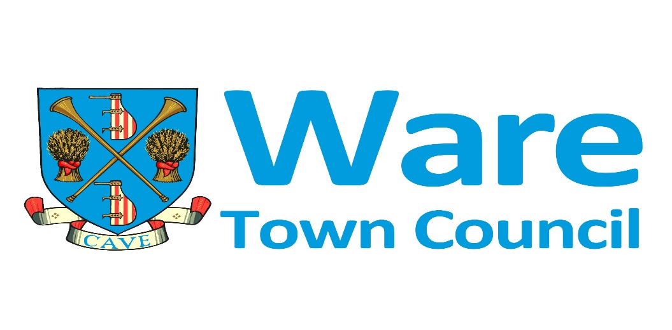

**WARE TOWN COUNCIL MEETING**

**Monday 24th March 2025**

in The Priory Hall, The Priory, Ware, starting at 7.30pm

MINUTES

Cllr Butcher (Chair) Day, Hill, Mowbray, Scully, Shaw, J Taylor-Moran, K Taylor-Moran Williams, Zsibrita

Officer present: Terry Philpott Town Clerk, Ros Montgomery (zoom).

Members of the public: x 2

**WTC990: To receive and accept Apologies for Absence**

* Cllr Bryant, Zsibrita

**WTC991: To receive any Declarations of Interest and review any requests for Dispensation submitted to the Clerk.**

* Cllr Hill WTC 994

**WTC992: Minutes from the previous meeting:** to receive and sign the minutes of the last Town Council meeting held on 24th February 2025

**Resolved:** The minutes are an accurate record

**WTC993: Correspondence and Clerks report (TP/5mins)**

Lido Building refurbishment, project group meeting to be held 27th March 2025

Fletchers Lea Refurbishment, completed apart from the curtains and some snagging.

Priory Lift update will be finished by 1st April 2025

Priory Grounds toilet refurbishment, opening event planned for Easter Saturday.

ATC visit January / February on Monday / Wednesday to view flight simulator.

East Herts Local Cycling and Walking Infrastructure Plan - Stakeholder Workshop 26/02/25 16:00

Supporting a campaign for child free smart phone update letter sent

Planting scheme in Ware, EHC advised that they can retain the beds and planting scheme

Citizens Advice Grant to be considered at the next meeting in April.

**WTC994: 3/25/0307/FUL request WTC consider application (GW/5mins)**

56 Musley Lane Ware Hertfordshire SG12 7EP

Retrospective partial change of use to use the front room as a hair salon

https://publicaccess.eastherts.gov.uk/online-applications/simpleSearchResults.do?action=firstPage

**Resolved:** To submit a response to the planning application with a neutral decision, the following observations

* Sunday and Bank Holidays not to be included in any permission due to the residential area the property is situated in.
* The hours should be restricted to 9am to 5pm Monday to Friday.

**WTC995 : Grant applications (TP/2mins)**





Crucial Crew Grant application update, to consider providing funding for the room hire in 2026. Crucial Crew to provide evidence of participation from Ware schools.

**WTC996: Events Report (RM/5mins)**

The Events report was discussed and noted.

**Round up 2024-25**

**Cinema**

526 people attended 8 afternoon films over the past year. The programme continues to be a valuable addition to the Ware calendar; both from an entertainment point of view and for community cohesion.

**Film Festival**

411 guests attended 9 free films screened at various venues throughout the town in October. The introduction of a foreign language film as part of the programme was successful and will continue.

**School holiday activities**

Approximately 2900 children attended school holiday activities across the year. The activities included archery, multi spots, various craft classes, free films, bungee trampolines, Lego workshops, silent disco, planting sessions, climbing wall, water wars and mini golf.

**Wellbeing**

For the period May 24-April 25 over 400 members of the community attended wellbeing events such as breathwork, midnight swim, laughing yoga, zentangle, sound journey, kickboxing, youth fitness programme and men’s retreat.

**Summer Concerts**

The programme of free summer concerts were well attended throughout the summer.

**Ware Festival 2024**

Despite dreadful weather on Carnival Day the parade went ahead, and the town fair was reasonably well attended. Carnival Day provides local groups and charities with the opportunity to raise funds and raise their profile within the town. The other Ware festival events throughout July, such as the Real Ale Festival, various competitions, etc., were well attended.

**D-Day 2024**

This commemorative event was well attended and appreciated by the community.

**Food Festival 2024**

This has become a well-established part of the Ware calendar and is well supported by both traders and the public.

**Programme of events for 2025-26**

**Cinema**

The programme is ongoing with the final film in the current season in May and will restart in September.

**VE Day – 8th May, 6pm-9.30pm**

This free, commemorative event will begin with a flag ceremony in the Priory grounds. There will be live music with the Miss Alex Jazz Band and interactive dance with Swing Dance UK. The evening will finish with the lighting of the beacon.

**Summer Concerts**

The following concerts will take place in the Priory grounds and will be free to attend:

|  |  |  |
| --- | --- | --- |
| **Band** | **Date** | **Concert timing** |
| Steve Young | 01/06/2025 | 3pm-5pm |
| Old Time Sailors | 14/06/2025 | Noon-2pm |
| Lulu & the Hullabaloos | 22/06/2025 | 3-5pm |
| Ware Brass | 06/07/2025 | 3-5pm |
| A Twist of Rock  Rock Legends Show | 13/07/2025 | 5.30pm-7pm  5pm-6pm 1st set  6.30-7.30pm 2nd set |
| Barry Sapsford’s Swing Orchestra | 03/08/2025 | 3pm -5pm |
| Steel Pan in Motion | 10/08/2025 | 3pm-5pm |
|  |  |  |
| Lip Service Brass Band  To be confirmed | 17/08/2025 | 3pm-5pm |
| Ware Brass | 07/09/2025 | 3pm-5pm |
| Ware Brass | 21/12/2025 | ?? |

**Wellbeing**

The wellbeing programme for 2025-26 is taking shape and will include the most popular activities from 2024-25 such as Zendoodle, Breathwork, a movement class, summer solstice swim, men’s retreat, and youth fitness programme/s. New for 2025-26 will be some Eat Well classes, Mighty Mind resilience classes and sleep reset classes. Confirmed to date are:

|  |  |  |
| --- | --- | --- |
| **Date/Time** | **Venue** | **Event type** |
| **APRIL** |  |  |
| Friday 11th  7-8pm | Fletcher’s Lea | Sound Journey |
| Wednesday 30th 7-8:30pm |  | Eat Well |
| **MAY** |  |  |
| Friday 9th 6:30-7:30pm |  | Breathwork |
| Wednesday 21st |  | Movement |
| **JUNE** |  |  |
| Friday 13th 7-8pm |  | Sound Journey |
| Saturday 21st | Lido | Ecstatic Dance & Swim – 2 sessions  6pm-10pm |
| Wednesday 25th 7-8:30pm |  | Eat Well |
| **JULY** |  |  |
| Wednesday 2nd 7-8pm |  | Movement |
| **AUGUST** |  |  |
|  |  |  |
| **SEPTEMBER** |  |  |
| Friday 12th |  | Breathwork |
| Wednesday 24th |  | Eat Well |
|  |  |  |
| **OCTOBER** |  |  |
| Friday 10th |  | Sound Journey |
| Wednesday 15th |  | Movement |
|  |  |  |
| **NOVEMBER** |  |  |
| Wednesday 12th |  | Mighty Mind |
| Friday 21st |  | Breathwork |

**School holiday activities**

The following school holiday activities are confirmed:

|  |  |  |
| --- | --- | --- |
| **Date** | **Concept** | **Provider** |
| Thursday 10th April  12-4pm | Silent Disco | **Silent Disco Company** |
| Tuesday 15th April  2pm-4pm | Children’s Film  Paddington in Peru | **WTC** |
| Saturday 19th April  1.30pm-3.15pm for judging | Easter Activities | **WTC** |

|  |  |  |
| --- | --- | --- |
| **Date** | **Concept** | **Provider** |
| 29th of May | Pop-up tennis, badminton, dodgeball, basketball, crazy catch, **ages 6 – 12** | **Sporting Inspirations** |
| 27th May | Planting session | **Ware in Bloom** |

|  |  |  |
| --- | --- | --- |
| **Date** | **Concept** | **Provider** |
| Tuesday 28th July  12-4pm | Archery | **5th Ware** |
| Thursday 31st July  12-4pm | Climbing Frame | **Xtreme Vortex** |
| Monday 25th August 2024  12-4pm | Water wars | **Tolmers Activity Centre** |
| Thursday 7th August 2024  12-4pm | Doodle Jam | **Fool’s Paradise** |
| Tuesday 12th August  11-5pm | Junk Percussion | **Primary Workshops** |
| Thursday 14th August | Ventura Classic Animal Adventure | **Ventura** |
| Tuesday 26th August  10:30-12:30 and 14:00-16:00  25 kids per session  5-11 age group | Bush craft | **Bush Craft** |
| Thursday 28th August | Multisport | **Horizon** |

**Ware Festival**

Carnival Day, the Town Fair, Riverside Real Ale Festival and all the other associated Ware Festival events are well underway. Carnival Day is Saturday, July 5th and

**WTC997: Use of Twitter / X within Ware Town Council (SF/5mins)**

To consider the continued use of this social media platform and review alternative options.

**Twitter/X Latest Stats**

**2952 Followers** (47 lost since November 2024, a possible correlation with US election). There also seems to be a number of dormant accounts of followers who no longer engage with the platform, as indicated by lower impressions.

Comparing the most recent 6-month period (Sep 2024 to Feb 2025) to the previous 6 months of Mar 2024 to Aug 2024 there has been a **77% drop in post impressions**, with 2,920 impressions in the last 6 months (The number of times tweets you published during the time frame were displayed on a person's screen) compared to 12,684 in the 6 months before that.

**However, post engagement rate is up 9%** this period suggesting those who are on the platform remain interested in our content. It is useful for signposting our monthly newsletter and events.

**Hootsuite**

All our social media accounts are managed via the Hootsuite social media management platform that means we can manage our accounts, schedule posts and engage with our followers, and analyse performance. We have the ability to manage 10 accounts, we are at capacity with our council, town centre, lido and Priory accounts.

**Bluesky**

We secured the Bluesky account for Ware Town Council in November when the popularity of the platform increased. Bluesky runs on a system that is not controlled by any one person or organization. Our handle is @waretowncouncil.bsky.social but we have not promoted our account, posted or tried to attract followers yet.

Unlike Twitter/X, Bluesky doesn’t yet have widespread adoption by local authorities. It would be worth us monitoring how the platform evolves and providing another update later this year before we take on managing another platform and building an audience.

**Resolved:** To stop using Twitter / X and migrate to BlueSky

**WTC998: Governance Review / Ware Boundary Change (TP/15mins)**

**To consider the councils response to the Governance Review for a boundary change to the North of Ware potentially encompassing the new development c1800 houses.**

After the close of the first stage of the consultation, the Community Governance Review Working Group (made up of East Herts Councillors) met on 6 February 2025 and proposed a list of draft recommendations, which were presented to the Full Council on 26 February 2025 and were approved for public consultation.

The Working Group considered submissions from Wareside Parish Council and Ware Town Council and proposed the following draft recommendations that the Council have accepted.

The boundary between Wareside, Ware and Tunbridge is left unchanged. At this stage this is only a draft recommendation, and the Review will be seeking the views of residents, stakeholders and will be looking at the timeline for the Ware 2 development to enable the Working Group and Council to make an informed decision for the final recommendation.

The next stage of the CGR is consultation on the draft recommendations from 3 March to 12 May 2025. The working group will then meet in June to consider all consultation responses and propose a set of final recommendations to the Council at its meeting on 23 July 2025.

**More information on the Review and how to respond can be found at** [**https://www.eastherts.gov.uk/elections-and-voting/community-governance-review**](https://www.eastherts.gov.uk/elections-and-voting/community-governance-review)

**In July 2022 WTC passed the following resolution, the report related to this resolution is in the agenda pack**

***Governance Review (IK)***

*The paper from Cllr Kemp provides more information on this item and is included in the agenda pack.*

***Resolved****: This Council requests the Town Clerk to contact the Head of Legal Services at East Herts District Council to request a Community Governance Review for Ware.*

*This recommendation is subject to the final outcome of the Local Government Boundary Commission for England (LGBCE) due to be published on 2 August 2022. The Council delegates the Leader of the Council and Town Clerk to make any changes to the request depending on the final proposals from the LGBCE.*

**Resolved:** To advocate for the boundary change as submitted in the initial request.

The electoral boundary has already been changed to support the boundary change

Residents of the new 1800 house development are likely to view Ware as the responsible parish.

Wareside will not be adversely impacted by the precept related to the exiting properties

**WTC999: Priory Park Swing (TP/5mins)**

**To install new swings**

**Project objective:** To repair mulch and install new child swing and inclusive swing

**Timescale:** To be confirmed

**Summary of works to be completed: Install new swings in priory grounds**

|  |  |  |  |  |
| --- | --- | --- | --- | --- |
| **Contractor** | A | B | C | D |
|  | Product not suitable | 17.495 | 23.700 |  |
|  |  |  |  |  |
|  |  |  |  |  |
| Total |  |  |  |  |

**Resolved:** To appoint contractor C based on the larger age range, greater number of users than contractor B.

**WTC1000: Financial Report (TP 5mins)**

Finance reports to 28th February 2025

* Bank Reconciliation inc reserve, earmarked funds.
* Debtor’s report
* Profit and Loss
* Departmental Profit and Loss showing total income and expenditure.

The report was not reviewed and will be distributed via email.

**WTC1001: Ware Town Council Bank Reconciliations 28.02.25 (TP 2mins).**

**Resolved**: To approve the above Bank Reconciliations Cllrs Mowbray and Day.

**WTC1002: Feedback from members of external groups (Cllrs / 5mins)**

* Friend of Ware Priory (GH)
* Town Twinning (KTM)
* Southern Maltings (RM)
* Ware Drill Hall (AZ)
* Ware Museum (BB)
* Ware Society (RM)
* Ware Charities (GW)
* Air Training Corps (TD)

**WTC1003: Feedback from working groups (Cllrs/10mins)**

* Councillor Diversity (KTM)
* Lido Working Group (TD)
* Biodiversity and Access to nature working group (GW)
* Town Centre improvements (Christmas Lights / Trees in Amwell End)

**WTC1004: Agenda items for next meeting (MB/1mins)**

Christmas Lights

**WTC1005: Mayor’s Closing Remarks (MB/1mins)**

To agree any items to be dealt with after the public, including the press have been excluded. (A resolution to be passed by Councillors)

**WTC1006: Fanshaw Pool Business Plan (TP/TD/20mins)**

The decision was deferred pending further information from Chauncey School, an additional meeting has been scheduled for 3rd April 2025 at 7.30pm.